**DAILY ONLINE ACTIVITIES SUMMARY**

|  |  |  |  |  |  |  |  |  |
| --- | --- | --- | --- | --- | --- | --- | --- | --- |
| **Date:** | **11-07-2020** | | | | | **Name:** | **Deeksha D Poojary** | |
| **Sem & Sec** | **VIII Semester & A Section** | | | | | **USN:** | **4AL16CS026** | |
| **Online Test Summary** | | | | | | | | |
| **Subject** | | **No test was conducted** | | | | | | |
| **Max. Marks** | | **-** | | **Score** | | | **-** | |
| **Certification Course Summary** | | | | | | | | |
| **Course** | **Introduction to Hadoop & Robotic Process Automation** | | | | | | | |
| **Certificate Provider** | | | **Great Learning & Ui Path** | | **Duration** | | | **4 Hours & 3 Hours** |
| **Coding Challenges** | | | | | | | | |
| **Problem Statement: Find the subarray in the array whose first element & second element must be same.** | | | | | | | | |
| **Status: COMPLETED** | | | | | | | | |
| **Uploaded the report in Github** | | | | | **YES** | | | |
| **If yes Repository name** | | | | | **deekshapoojari** | | | |
| **Uploaded the report in slack** | | | | | **YES** | | | |

Online Test Details:

NIL

Certification Course Details:

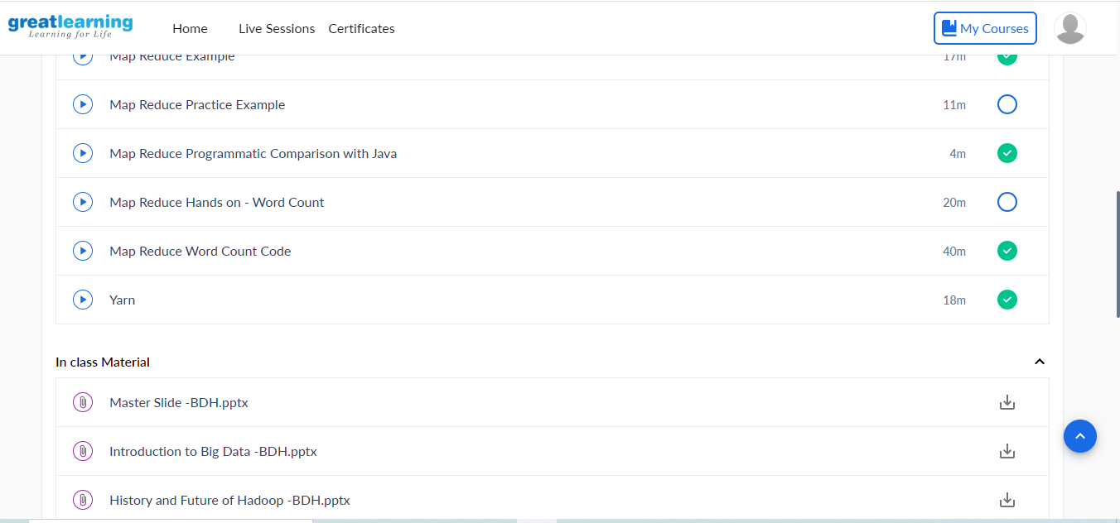

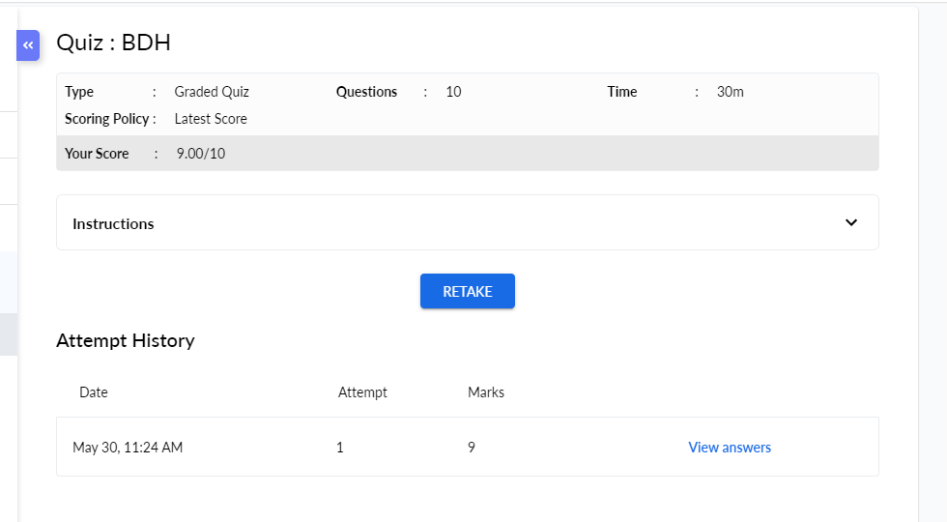

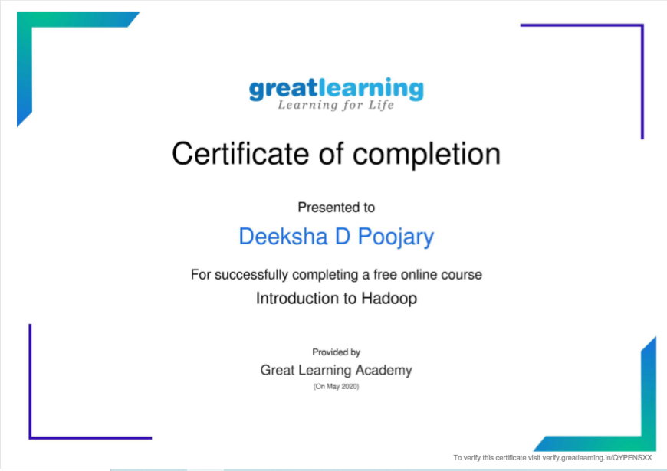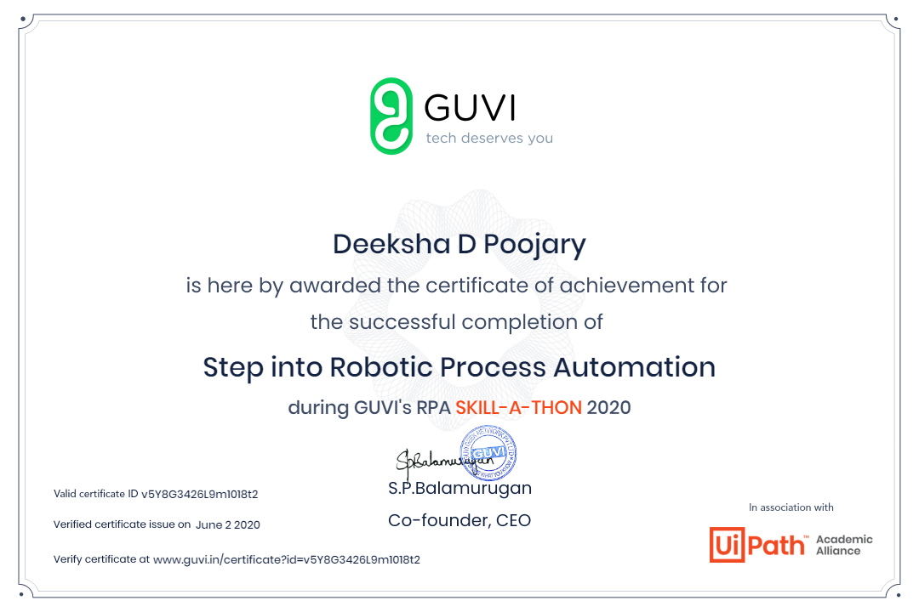

Coding Challenges Details:

|  |
| --- |
|  |
|  |
|  |
|  |
|  |
|  |
|  |
|  |
|  |
|  |
|  |
|  |
|  |
|  |
|  |
|  |
|  |
|  |
|  |
|  |
|  |
|  |
|  |
|  |
|  |
|  |
|  |
|  |
|  |
|  |
|  |
|  |
|  |
|  |
|  |
|  |
|  |
|  |
|  |
|  |
|  |
|  |
|  |
|  |
|  |
|  |
|  |
|  |
|  |
|  |
|  |
|  |
|  |
|  |

**Program1:**

|  |
| --- |
| **#include<stdio.h>** |
|  |  |
|  | **void main()** |
|  | **{** |
|  | **int a[] = {1, 2, 1, 5, 2};** |
|  | **int n = sizeof(a) / sizeof(int);** |
|  | **int result = 0, val, i ,j;** |
|  |  |
|  | **for(i=0; i<n; i++)** |
|  | **{** |
|  | **result ++;** |
|  | **val = a[i];** |
|  |  |
|  | **for(j=i+1; j<n; j++)** |
|  | **{** |
|  | **if(a[j] == val)** |
|  | **result++;** |
|  | **}** |
|  | **}** |
|  | **printf("%d",result);** |
|  | **}** |